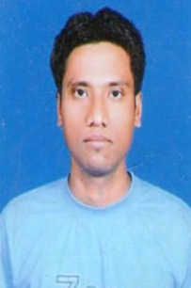
CURRICULUM VITAE
PRANJAL GOGOI
Khanamukh charingia gaon
P.o-khanamukh, dist- jorhat
Emai:- Pranjalpran.a@gmail.com
Mob- 9101123324

OBJECTIVE:
To enhance my knowledge and capability by working in a dynamic organization that prides itself in giving substantial responsibility to new talent.

PERSONAL INFORMATION:
- Father’s name : Krishna Gogoi
- Date of birth : 31/08/1988
- Gender : Male
- Nationality : Indian
- Marital status : Married

EDUCATION QUALIFICATION:
- B.A Pass from Sibsagar College, Joysagar.
- Higher Secondary From Khanamukh H.S. School.
- Matriculation From Khanamukh H.S.School.

OTHER SKILLS:
- Post graduate diploma in computer application from APIIT, Jorhat.
- Hardware & Networking course from Disha Computer , Pune.
- 3 Months tally course From Global Computer Institute , Teok.

EXPERIENCE:
- 1 year experience in NRC as a data entry operator.
- 2 years experience in Khanamukh H.S.School as a computer Teacher.

HOBBIES:
- Use Computer.
- Listening song.

LANGUAGES:
- Assamese.
- English.
- Hindi.

